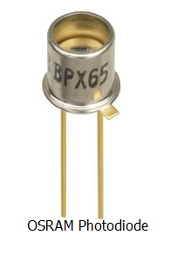 **PHOTODIODE**

**Introduction**

* A photodiode is a p-n junction or pin semiconductor device that consumes light energy to generate electric current. It is also sometimes referred as photo-detector, photo-sensor, or light detector.
* Photodiodes are specially designed to operate in reverse bias condition. Reverse bias means that the p-side of the photodiode is connected to the negative terminal of the battery and n-side is connected to the positive terminal of the battery.
* Photodiode is very sensitive to light so when light or photons falls on the photodiode it easily converts light into electric current. Solar cell is also known as large area photodiode because it converts solar energy or light energy into electric energy. However, solar cell works only at bright light.
* The construction and working of photodiode is almost similar to the normal [p-n junction diode](https://www.physics-and-radio-electronics.com/electronic-devices-and-circuits/semiconductor-diodes/pnjunctionsemiconductordiode.html). PIN (p-type, intrinsic and n-type) structure is mostly used for constructing the photodiode instead of p-n (p-type and n-type) junction structure because PIN structure provide fast response time. PIN photodiodes are mostly used in high-speed applications.
* In a normal p-n junction diode, [voltage](https://www.physics-and-radio-electronics.com/electromagnetics/electrostatics/potential-difference.html) is used as the [energy](https://www.physics-and-radio-electronics.com/physics/energy/what-is-energy.html) source to generate electric current whereas in photodiodes, both voltage and light are used as energy source to generate electric current.

Photodiode symbol

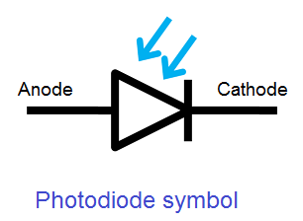The symbol of photodiode is similar to the normal p-n junction diode except that it contains arrows striking the diode. The arrows striking the diode represent light or photons.

A photodiode has two terminals: a cathode and an anode.

**Objectives and limitations of photodiode**

1. Photodiode should be always operated in reverse bias condition.
2. Applied reverse bias voltage should be low.
3. Generate low noise
4. High gain
5. High response speed
6. High sensitivity to light
7. Low sensitivity to temperature
8. Low cost
9. Small size
10. Long lifetime

**How photodiode works?**

* A normal p-n junction diode allows a small amount of electric current under reverse bias condition. To increase the electric current under reverse bias condition, we need to generate more minority carriers.
* The external reverse voltage applied to the p-n junction diode will supply energy to the minority carriers but not increase the population of minority carriers.
* However, a small number of minority carriers are generated due to external reverse bias voltage. The minority carriers generated at n-side or p-side will recombine in the same material before they cross the junction. As a result, no electric current flows due to these charge carriers. For example, the minority carriers generated in the p-type material experience a repulsive force from the external voltage and try to move towards n-side. However, before crossing the junction, the free electrons recombine with the holes within the same material. As a result, no electric current flows.
* To overcome this problem, we need to apply external energy directly to the [depletion region](https://www.physics-and-radio-electronics.com/electronic-devices-and-circuits/semiconductor-diodes/depletion-region.html) to generate more charge carriers.
* A special type of diode called photodiode is designed to generate more number of charge carriers in depletion region. In photodiodes, we use light or photons as the external energy to generate charge carriers in depletion region.

**Types of photodiodes**

The working operation of all types of photodiodes is same. Different types of photodiodes are developed based on specific application. For example, PIN photodiodes are developed to increase the response speed. PIN photodiodes are used where high response speed is needed.

The different types of photodiodes are

* PN junction photodiode
* PIN photodiode
* Avalanche photodiode

Among all the three photodiodes, PN junction and **PIN photodiodes are most widely used.**

**PN junction photodiode**

* PN junction photodiodes are the first form of photodiodes. They are the most widely used photodiodes before the development of PIN photodiodes. PN junction photodiode is also simply referred as photodiode. Nowadays, PN junction photodiodes are not widely used.
* 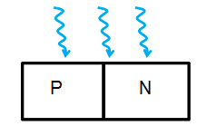
* When external light energy is supplied to the p-n junction photodiode, the [valence electrons](https://www.physics-and-radio-electronics.com/electronic-devices-and-circuits/introduction/valence-electrons.html) in the depletion region gains energy.
* If the light energy applied to the photodiode is greater the band-gap of semiconductor material, the valence electrons gain enough energy and break bonding with the parent [atom](https://www.physics-and-radio-electronics.com/electronic-devices-and-circuits/introduction/atom.html). The valence electron which breaks bonding with the parent atom will become free electron. Free electrons moves freely from one place to another place by carrying the electric current.
* When the valence electron leave the valence shell an empty space is created in the valence shell at which valence electron left. This empty space in the valence shell is called a hole. Thus, both free electrons and holes are generated as pairs. The mechanism of generating electron-hole pair by using light energy is known as the inner photoelectric effect.
* The minority carriers in the depletion region experience force due to the depletion region [electric field](https://www.physics-and-radio-electronics.com/electromagnetics/electrostatics/electric-field.html) and the external electric field. For example, free electrons in the depletion region experience repulsive and attractive force from the negative and positive ions present at the edge of depletion region at p-side and n-side. As a result, free electrons move towards the n region. When the free electrons reaches n region, they are attracted towards the positive terminals of the battery. In the similar way, holes move in opposite direction.
* 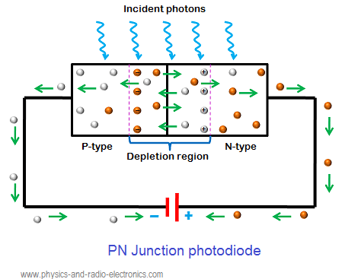
* The strong depletion region electric field and the external electric field increase the drift velocity of the free electrons. Because of this high drift velocity, the minority carriers (free electrons and holes) generated in the depletion region will cross the p-n junction before they recombine with atoms. As a result, the minority carrier current increases.
* When no light is applied to the reverse bias photodiode, it carries a small reverse current due to external voltage. This small electric current under the absence of light is called dark current. It is denoted by Iλ.
* In a photodiode, reverse current is independent of reverse bias voltage. Reverse current is mostly depending on the light intensity.
* In photodiodes, most of the electric current is carried by the charge carriers generated in the depletion region because the charge carriers in depletion region has high drift velocity and low recombination rate whereas the charge carriers in n-side or p-side has low drift velocity and high recombination rate. The electric current generated in the photodiode due to the application of light is called photocurrent.
* The total current through the photodiode is the sum of the dark current and the photocurrent. The dark current must be reduced to increase the sensitivity of the device.
* The electric current flowing through a photodiode is directly proportional to the incident number of photons.

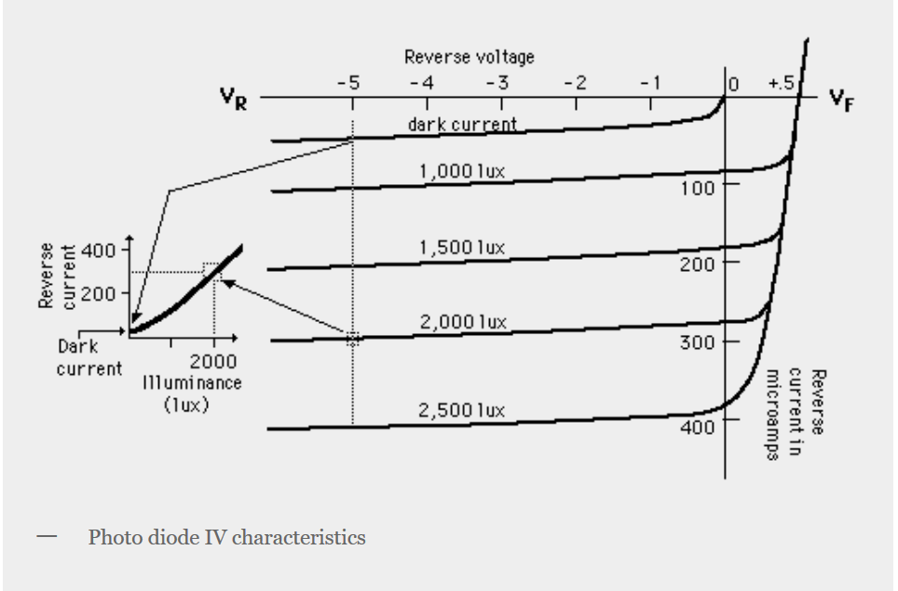

PIN photodiode

* PIN photodiodes are developed from the PN junction photodiodes. The operation of PIN photodiode is similar to the PN junction photodiode except that the PIN photodiode is manufactured differently to improve its performance.
* The PIN photodiode is developed to increase the minority carrier current and response speed.
* PIN photodiodes generate more electric current than the PN junction photodiodes with the same amount of light energy.

**Layers of PIN photodiode**

* A PN junction photodiode is made of two layers namely p-type and n-type semiconductor whereas PIN photodiode is made of three layers namely p-type, n-type and intrinsic semiconductor.
* In PIN photodiode, an addition layer called intrinsic semiconductor is placed between the p-type and n-type semiconductor to increase the minority carrier current.

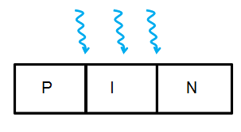

**PIN photodiode operation**

* A PIN photodiode is made of p region and n region separated by a highly resistive intrinsic layer. The intrinsic layer is placed between the p region and n region to increase the width of depletion region.
* The p-type and n-type semiconductors are heavily doped. Therefore, the p region and n region of the PIN photodiode has large number of charge carriers to carry electric current. However, these charge carriers will not carry electric current under reverse bias condition.
* On the other hand, intrinsic semiconductor is an undoped semiconductor material. Therefore, the intrinsic region does not have charge carriers to conduct electric current.
* Under reverse bias condition, the majority charge carriers in n region and p region moves away from the junction. As a result, the width of depletion region becomes very wide. Therefore, majority carriers will not carry electric current under reverse bias condition.
* However, the minority carriers will carry electric current because they experience repulsive force from the external electric field.
* In PIN photodiode, the charge carriers generated in the depletion region carry most of the electric current. The charge carriers generated in the p region or n region carry only a small electric current.
* When light or photon energy is applied to the PIN diode, most part of the energy is observed by the intrinsic or depletion region because of the wide depletion width. As a result, a large number of electron-hole pairs are generated.
* Free electrons generated in the intrinsic region move towards n-side whereas holes generated in the intrinsic region move towards p-side. The free electrons and holes moved from one region to another region carry electric current.
* When free electrons and holes reach n region and p region, they are attracted to towards the positive and negative terminals of the battery.
* 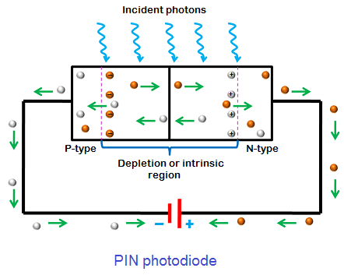
* The population of minority carriers in PIN photodiode is very large compared to the PN junction photodiode. Therefore, PIN photodiode carry large minority carrier current than PN junction photodiode.
* When forward bias voltage is applied to the PIN photodiode, it behaves like a resistor.
* We know that capacitance is directly proportional to the size of electrodes and inversely proportional to the distance between electrodes. In PIN photodiode, the p region and n region acts as electrodes and intrinsic region acts as dielectric.
* The separation distance between p region and n region in PIN photodiode is very large because of the wide depletion width. Therefore, PIN photodiode has low capacitance compared to the PN junction photodiode.
* In PIN photodiode, most of the electric current is carried by the charge carriers generated in the depletion region. The charge carriers generated in p region or n region carry only a small electric current. Therefore, increasing the width of depletion region increases the minority carrier electric current.

**Advantages of PIN photodiode**

1. **Wide bandwidth**
2. **High quantum efficiency**
3. **High response speed**

**Avalanche photodiode**

* The operation of avalanche photodiode is similar to the PN junction and PIN photodiode except that a high reverse bias voltage is applied in case of avalanche photodiode to achieve avalanche multiplication.
* Applying high reverse bias voltage to the avalanche photodiode will not directly increase the generation of charge carriers. However, it provides energy to the electron-hole pairs generated by the incident light.
* When light energy is applied to the avalanche photodiode, electron-hole pairs are generated in the depletion. The generated electron-hole pairs experience a force due to the depletion region electric field and external electric field.
* In avalanche photodiode, a very high reverse bias voltage supply large amount of energy to the minority carriers (electron-hole pairs). The minority carriers which gains large amount of energy are accelerated to greater velocities.
* When the free electrons moving at high speed collides with the atom, they knock off more free electrons. The newly generated free electrons are again accelerated and collide with other atoms. Because of this continuous collision with atoms, a large number of minority carriers are generated. Thus, avalanche photodiodes generates more number of charge carriers than PN and PIN photodiodes.
* Avalanche photodiodes are used in the applications where high gain is an important factor

Advantages of avalanche photodiode

* High sensitivity
* Larger gain

Disadvantages of avalanche photodiode

Generates high level of noise than a PN photodiode

Photodiode operation modes

A photodiode can be operated in one of the two modes: photovoltaic mode or photoconductive mode.

Operation mode selection of the photodiode is depends upon the speed requirements of the application and the amount of dark current that is tolerable.

Photovoltaic mode

In the photovoltaic mode, the photodiode is unbiased. In other words, no external voltage is applied to the photodiode under photovoltaic mode.

In photovoltaic mode, dark current is very low. Photodiodes operated in photovoltaic mode have low response speed.

The photodiodes operated in photovoltaic mode are generally used for low speed applications or for detecting low light levels.

Photoconductive mode

In photoconductive mode, an external reverse bias voltage is applied to the photodiode.

Applying a reverse bias voltage increases the width of depletion region and reduces the junction capacitance which results in increased response speed. The reverse bias also increases the dark current.

Photodiodes operated in photoconductive mode has high noise current. This is due to the reverse saturation current flowing through the photodiode.

Dark current

Dark current is the leakage current that flows in the photodiode in the absence of light. The dark current in the photodiode increases when temperature increases. The material used to construct the photodiode also affects the dark current.

The different materials used to construct photodiodes are Silicon (Si), Germanium, (Ge), Gallium Phosphide (GaP), Indium Gallium Arsenide (InGaAs), Indium Arsenide Antimonide (InAsSb), Extended Range Indium Gallium Arsenide (InGaAs), Mercury Cadmium Telluride (MCT, HgCdTe).

Germanium, Indium Arsenide Antimonide, Indium Gallium Arsenide and Mercury Cadmium Telluride generates large dark current because they are very sensitive to temperature.

The response speed of Silicon, Gallium Phosphide, Indium Gallium Arsenide and Extended Range Indium Gallium Arsenide is very high.

Performance parameters of a photodiode

Responsivity

Responsivity is the ratio of generated photocurrent to the incident light power.

Quantum efficiency

Quantum efficiency is defined as the ratio of the number of electron-hole pairs (photoelectrons) generated to the incident photons.

Response time or transit time

The response time of a photodiode is defined as the time it takes for light generated charge carriers to cross p-n junction.

Photodiode applications

The various applications of photodiodes are

1. Compact disc players
2. Smoke detectors
3. Space applications
4. Photodiodes are used in medical applications such as computed tomography, instruments to analyze samples, and pulse oximeters.
5. Photodiodes are used for optical communications.
6. Photodiodes are used to measure extremely low light intensities.